

FACULTY OF INFORMATION AND COMMUNICATION TECHNOLOGY
DCOMP320-Data Structures & Algorithm Analysis

Title : Individual Assignment
Issue Date : Week 2
Due Date : Week 4
Lecturer/Examiner :Miss Hawa Kallon
Name of Student : Abubakar Jalloh
Student ID No. : 905005148
Class : BSEM 2101
Semester/Year : 5/3

Academic Honesty Policy Statement

I, hereby attest those contents of this attachment are my own work. Referenced works, articles, art, programs, papers or parts thereof are acknowledged at the end of this paper. This includes data excerpted from CD-ROMs, the Internet, other private networks, and other people’s disk of the computer system.

Student’s Signature: ………………………………. Date:…………………………………………
LECTURER’S COMMMENTS/GRADE:

for office use only upon receive
Remark

DATE :………………………………….
TIME : ………………………………....
RECEIVER’S NAME :………………….

Table of Contents
- Introduction………………………………………………………………………………………………1
- Data Structures Used…………………………………………………………………………………2
- Program Design………………………………………………………………………………………..3
- Testing and Results……………………………………………………………………………………5
- Screenshot of Code……………………………………………………………………………………6
- Conclusion………………………………………………………………………………………………..7

Introduction
Data structures provide a systematic way to organize information so that programs can process it efficiently. One important data structure is the stack, which stores items in a Last In, First Out (LIFO) order. Stacks are especially useful when the order of operations matters, such as evaluating mathematical expressions containing brackets and arithmetic operators.
The purpose of this assignment is to implement a Python program that reads expressions from an input text file, evaluates them using a stack-based method, and saves the answers to an output text file. Each mathematical expression occupies one line, while separator lines remain unchanged. This demonstrates both algorithm design and basic file handling in Python.
The program supports addition (+), subtraction (-), multiplication (*), division (/), and parentheses. It follows the usual mathematical precedence rules: multiplication and division are evaluated before addition and subtraction, while parentheses determine which subexpression must be calculated first. The application uses a dedicated Stack class instead of relying on Python’s eval() function.
The main objectives are to implement push, pop, and peek operations; use stacks to manage numbers and operators; preserve the structure of the input file; and verify that the calculated results are correct.

1

Data Structures Used

1 The Stack and LIFO Principle
A stack is a linear data structure in which insertion and removal take place at one end, called the top. LIFO means the most recently inserted item is the first one removed. For example, if the values 4, 7, and 9 are pushed in that order, popping the stack returns 9 first, followed by 7 and then 4.
In this program, two stacks are used together. The values stack holds numbers and intermediate answers. The operators stack holds arithmetic operators and opening parentheses until they are ready to be applied. This arrangement makes it possible to evaluate expressions in the correct sequence.

2 Stack Operations
Operation | Purpose | Example
push(item) | Adds an item to the top of the stack | push(5)
pop() | Removes and returns the top item | pop() returns 5
peek() | Returns the top item without removing it | peek() returns 5
is_empty() | Checks whether the stack contains any items | True or False
These operations are implemented by a Python class using a list for internal storage. Pushing uses append(), while popping removes the last list element. The class also checks for empty-stack conditions to avoid silently using invalid values.

2.Importance of Stacks
Stacks are used in function calls, undo features in text editors, browser navigation, syntax checking, and expression parsing. In expression evaluation, stacks are particularly important because operators must sometimes wait until higher-priority calculations or parenthesized groups are completed.

2

Program Design

1 Project Files and Architecture
File | Description
main.py | Defines the stack and evaluates mathematical expressions.
input.txt | Contains expressions and separator lines for processing.
output.txt | Contains calculated answers in the same line structure.
README.md | Explains installation, execution, and project limitations.
The program follows a simple file-processing workflow: input.txt → read each line → identify separator or expression → tokenize and evaluate → format result → write output.txt. Separators are copied to the output rather than evaluated.

2 Expression Evaluation Algorithm
First, the expression is divided into meaningful tokens such as numbers, operators, and parentheses. Numbers are pushed onto the values stack. Operators are compared with the operator at the top of the operators stack. When the stacked operator has higher or equal precedence, the program applies that operator before pushing the new one. Opening parentheses are pushed to mark the start of a group, and closing parentheses cause operations to be performed until the matching opening parenthesis is reached.
To apply an operator, the program pops the right operand and then the left operand from the values stack. It performs the required arithmetic calculation and pushes the result back onto the values stack. After all input tokens are processed, remaining operators are applied. The final value left on the values stack is the answer.

3

3 Key Functions and Error Handling
The Stack class provides the basic operations. The tokenize() function separates an expression into tokens. The evaluate() function applies operator precedence and

parentheses using the two stacks. The process_file() function reads input.txt, preserves separator lines, evaluates expressions, and writes output.txt.
The implementation also provides error handling for invalid expressions and division by zero. Rather than stopping the entire file-processing task when an expression fails, it can record an error for that line and continue with later expressions. This makes the program more reliable when processing multiple lines.

4

Testing and Results

1. Sample Input and Output
The following examples were taken from the assignment and tested by running python main.py in the project directory. The program reported that five lines were processed and the results were saved to output.txt.
Input expression | Expected result | Actual result | Status
3 + 5 * 2 | 13 | 13 | Pass
(8 / 4) + 7 * 2 | 16 | 16 | Pass
10 - (2 + 3) * 4 | -10 | -10 | Pass
The input and output also contain separator lines made of hyphens. These lines were preserved between the results, maintaining the format requested in the assignment. The second expression evaluates to 16, since 8 / 4 = 2 and 7 * 2 = 14; the example output image in the brief appears to show 17, which is an arithmetic inconsistency.

2. Test Cases and Discussion
The first expression verifies precedence: multiplication is performed before addition. The second checks both parentheses and division. The third tests a parenthesized sum, multiplication, subtraction, and a negative final result. Together, these cases demonstrate that the two-stack approach can correctly manage operator order.
Additional recommended tests are 2 * (3 + 4), which should return 14; 12 / 4, which should return 3; and 8 / 0, which should produce an error instead of a numerical result. These additional cases are suggested for further verification and are not presented as executed test results.
The confirmed sample results show that the program meets the main requirement of evaluating expressions from a file and producing the corresponding output. A limitation is that the program is intended for arithmetic expressions, not arbitrary Python statements or scientific functions.

5

Screenshot Of Python work

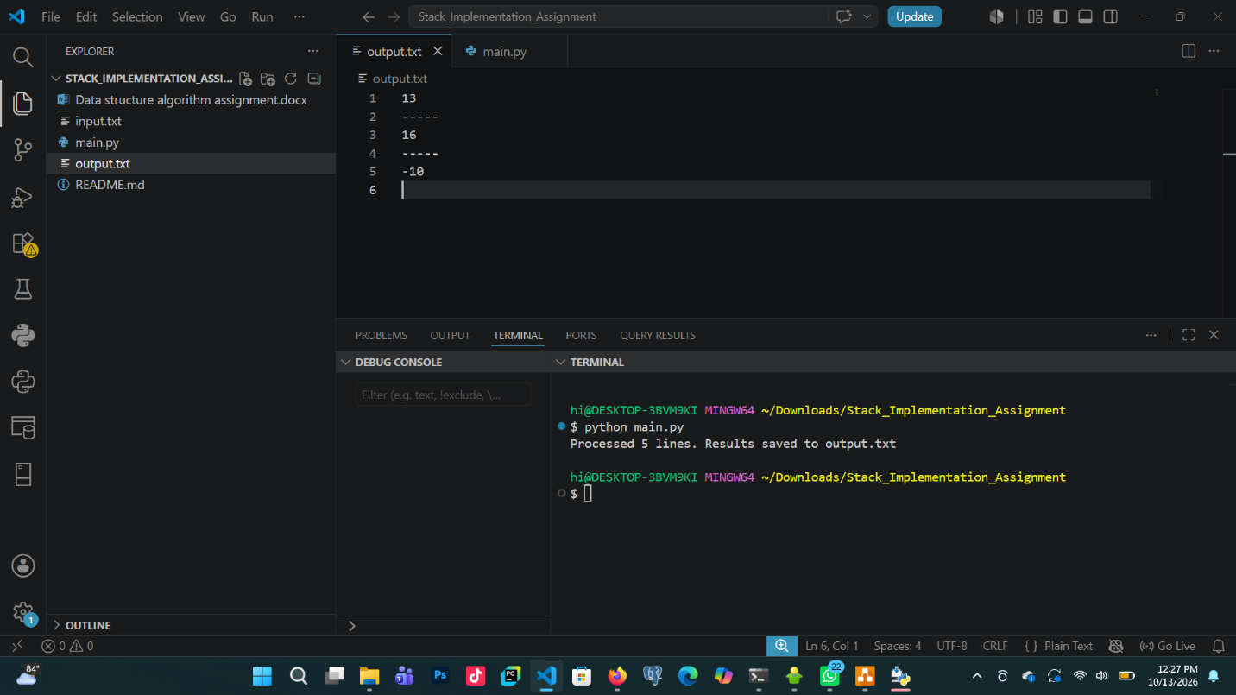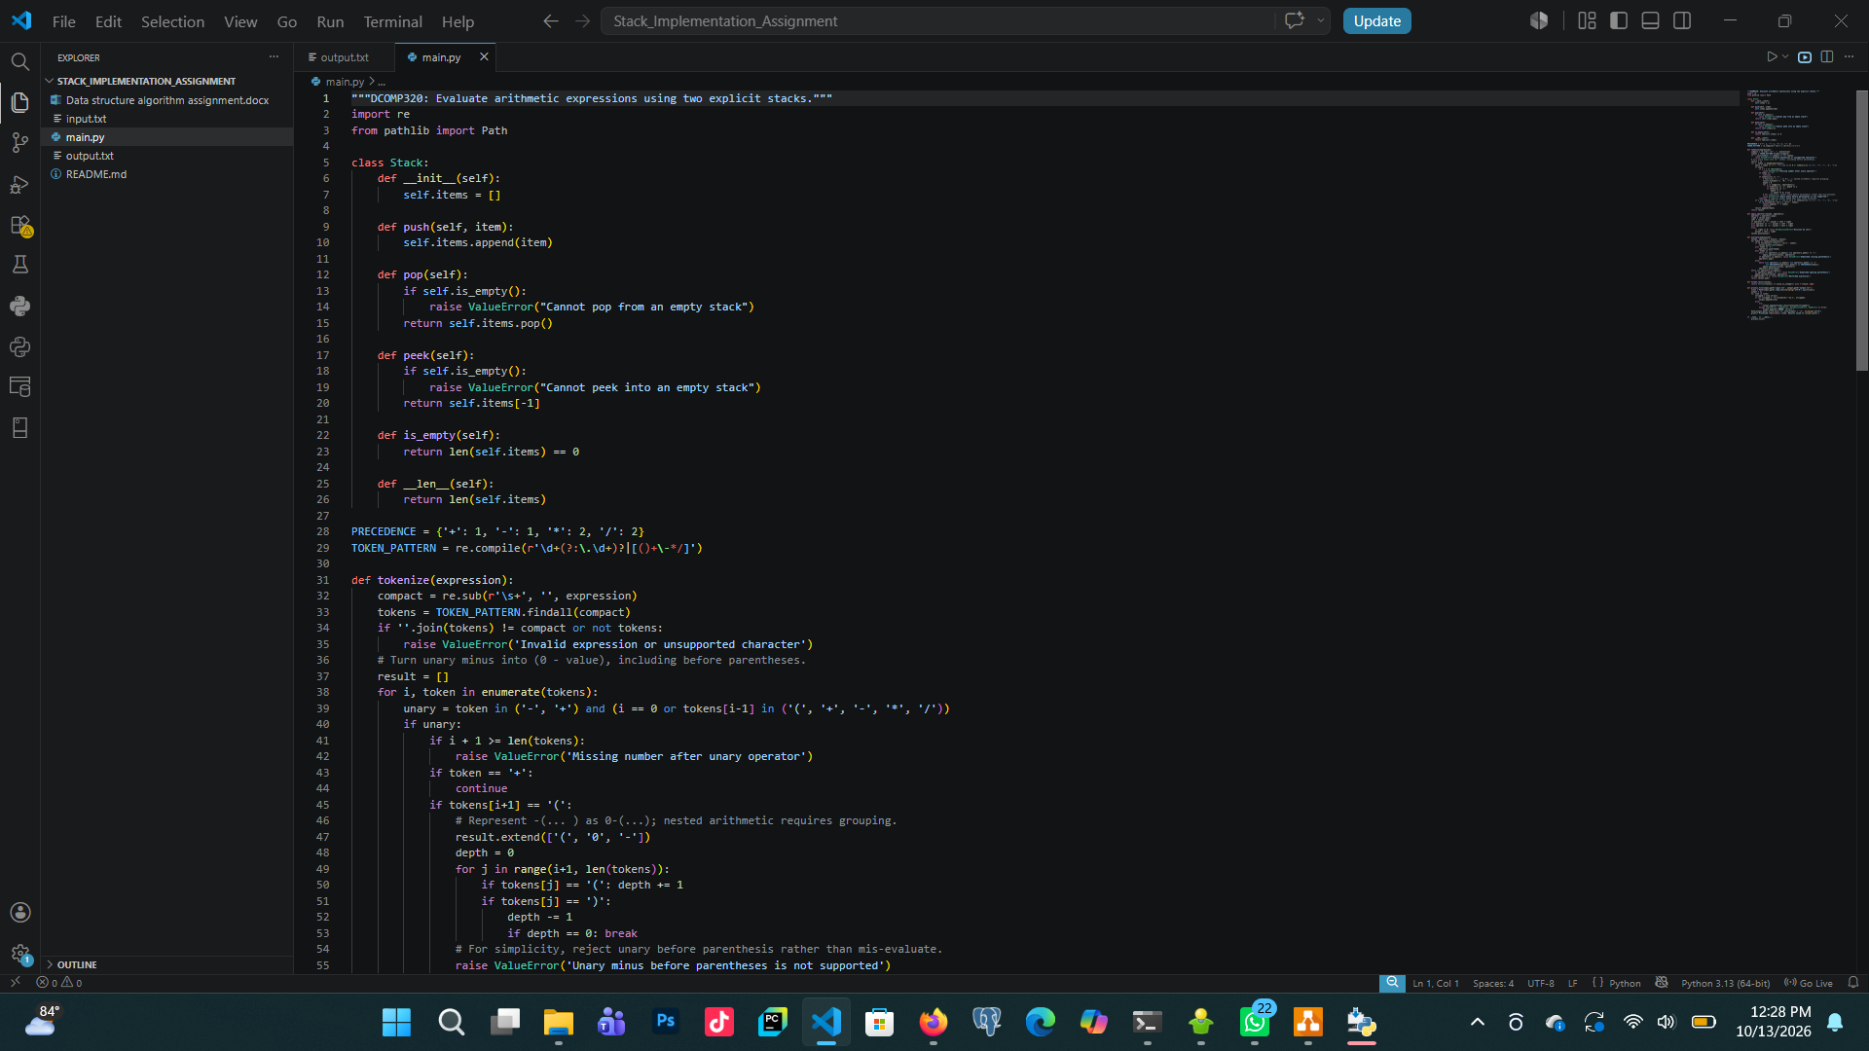

6

Conclusion
This assignment successfully demonstrates the use of a stack data structure in a practical Python application. By storing operands and operators separately, the program handles precedence and parentheses without using Python’s eval() function. The program also reads input from a text file and writes the answers to a second file while retaining separator lines.
Testing the three supplied mathematical expressions produced the correct results: 13, 16, and -10. The exercise strengthens understanding of stack operations, algorithmic problem-solving, file handling, and testing. Possible future improvements include a graphical interface, more detailed error messages, and support for additional mathematical functions.
The completed source code and supporting files should be uploaded to GitHub, and the lecturer should be added as a collaborator as required by the assignment instructions.

References
Limkokwing University of Creative Technology. (2026). DCOMP320: Data Structures and Algorithm — Stacks Implementation assignment brief.
Python Software Foundation. (n.d.). Python 3 documentation. https://docs.python.org/3/

7

